
Ministry of Higher Education and Scientific Research
HassibaBenbouali University of Chlef
Faculty of Exact Sciences and Computer Science
1st year MI
Module: Algorithmic and data structure 2
Tutorial N° 09: Linked list
Exercise 01:
Consider the following two C programs. Execute both and deduce the difference between them and the cause of this difference.
#include <stdio.h>  // fonction de permutation  void swap(int a, int b) {  int temp;  temp = a;  a = b;  b = temp;  printf("in this function : a = %d, b = %d\n", a, b);  }  int main() {  int x = 5, y = 10;  printf("before swap : x = %d, y = %d\n", x, y);  swap(x, y);  printf("After calling function : x = %d, y = %d\n", x, y);  return 0;  } | #include <stdio.h>  // fonction de permutation  void permuter(int *a, int *b) {  int temp;  temp = *a;  *a = *b;  *b = temp;  }  int main() {  int x = 5, y = 10;  printf("before swap : x = %d, y = %d\n", x, y);  permuter(&x, &y);  printf("after swap : x = %d, y = %d\n", x, y);  return 0;  }

Exercise 02:
- We want to represent a list of words using linked lists, where each element of the list is defined by a word (character string) and the address of the next item.
- Write the declaration of this structure.
- Write a sub-algorithm, which takes a list of words as an argument and returns the number of elements contained in this list.
- Write a sub-algorithm, which takes as arguments a list of words and a word M, then inserts a new element (for which the user is asked to enter the content) after the element that contains the word M in the list.
Example: we want to insert a new element in the list L after the element, which contains “Univ”, the user will enter Chlef for example:
Before insertion:
After insertion:
Exercise 03 :
Given two singly linked lists L1 and L2, write a sub-algorithm which allows you to concatenate the two lists L1 and L2 in such a way that L1 will represent the result list.

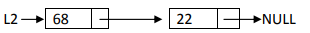
Example: Before concatenation:
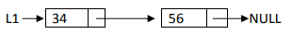
After concatenation:

Exercise 04:
We want to represent a list of integers using doubly linked lists, where each element contains the address of the next element and the address of the previous element.
(1) Write the declaration of this structure.
(2) Write a sub-algorithm which takes as argument a doubly linked list of integers and displays the elements from the list in both directions
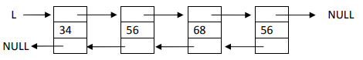
- Display (Left – Right): 34 56 68 56
- Display (Right – Left): 56 68 56 34

Exercise 05:
Consider a doubly linked list of integers (as shown in the diagram below), write the sub-algorithms which allow you to carry out the following operations:
• Insert an item at the top of the list.
• Delete the first element of the list (the head).
• Insert an element at the bottom of the list.
• Remove the last element from the list (the tail).

Exercise 06:
Given a circular list of integers, write a sub-algorithm which takes as argument a circular list, and which transforms it into a simply chained list.
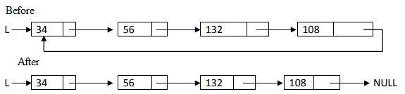

Exercise 07:
Given two circular lists L1 and L2, write a sub-algorithm which allows you to concatenate the two lists L1 and L2 such that L1 will represent the result list.
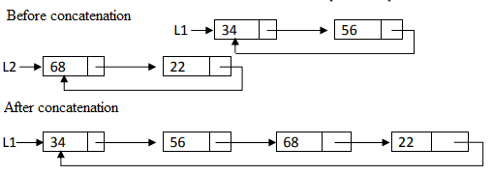

Additional exercises

Exercise 08:
Write a sub-algorithm that takes a singly ordered linked list as an argument of integers (sorted in ascending order) and which reverses the sort order, which means: the list before execution is sorted in ascending order, after execution it becomes sorted by descending order.
Example: Before:
After :
Exercise 09:
Write a sub-algorithm that takes as arguments a singly linked list of integers and an Integer X, and which deletes from the list the first occurrence of the element that contains X
Example: before:

After deletion of the element witch contains 56:

Exercise 10:
Consider a singly ordered linked list of integers (the elements are sorted in ascending order).
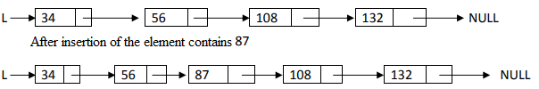
- Write a sub-algorithm ,which takes a linked list as an argument and which allows you to insert an element in this list, but on the condition that the list will remain sorted after insertion.
Exercise 11:
Consider two singly ordered lists L1 and L2 (sorted in ascending order), writing a sub-algorithm which makes it possible to concatenate the two lists L1 and L2 such that L1 represents the result list and it must be sorted in ascending order).

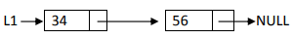
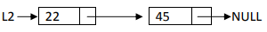
Before concatenation:
After concatenation:

Exercise 12:
Write a sub-algorithm that takes as arguments a singly linked list of integers and an integer X and which removes from the list all occurrences of elements that contains X.
Before: 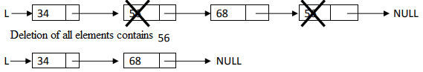
Exercise 13:
We want to represent an array of integers using a doubly linked list, where each element knows the address of the next element and the address of the previous element.
(1) Write the declaration of this structure.
(2) Write a subroutine that takes as argument a doubly linked list of integers and an integer X, removes from the list all occurrences of elements that contain X.
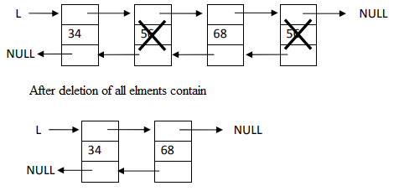

Exercise 14:
Consider a circular list of integers (as shown in the diagram below), writing the sub-algorithm that allow you to perform the following operations:
• Insert an item at the top of the list.
• Delete the first element of the list (the head).
• Insert an item into the list queue.
• Remove the last item from the list (the queue).
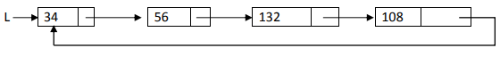
Example of a circular list:

“C’est en forgeant qu’on devient forgeron.”

